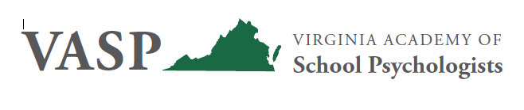
PROGRAM PROPOSAL
VASP 2022 Fall Conference Presentations on September 22-23
Conference Location: Omni Richmond, Richmond, VA
Conference Theme: Fostering Psychological Safety for School Success
Note: In the event that the conference must be held virtually due to COVID-19 restrictions, please indicate whether you are willing and able to present via webinar: ____ Yes _____ No
Length of Presentation: __ 1.5 hours __ 3 hours __ Other (please indicate length): _______
__ Poster Presentation for the VASP Graduate Student Showcase
In space below, provide brief abstract (approx. 50-80 words) of your proposal. (Please note that this description will be used in the Conference Program if your presentation is selected.)
__
In space below, provide specific Learning Objectives for your presentation; please include at least two, or one objective per hour if your presentation is more than two hours. Refer to the NASP Website for clarification regarding writing Learning Objectives. (Please note that these Learning Objectives will be used in the Conference Program if your presentation is selected.)
__
Presenter Information for Program: Please list name(s) and degree(s) exactly as you want them listed in the program.
Name: ____ Degree(s):______ Organization/Affiliation: ________
Name: ____ Degree(s):______ Organization/Affiliation: ________
Name: ____ Degree(s):______ Organization/Affiliation: ________

Proposal Submitted By (Contact Information):
Name:
Email:
Cell Phone:
** Audio Visual Equipment Required (note that presenters are expected to provide their own computer/laptop):
__ Microphone ___ LCD Projector and Screen __ Internet __ Other ___________________
Special A/V equipment such as VCRs and monitors, tape recorders, etc. require special arrangements and require advance notice. Laptops are to be provided by the presenter.

Any special accommodations needed for the presenter? _______

Send completed proposal by email to Tiffany Hornsby, VASP President-Elect, and hornsbtc@jmu.edu and please copy Kelly Acevedo, VASP Past President, at kacevedo@bcpschools.org.

PROPOSALS MUST BE RECEIVED NO LATER THAN AUGUST 12, 2022
Selections of presentations are made by the VASP Executive Board and Conference Committee. Due to the number of proposal received as well as space and time constraints, we regret that not all presentations may be accepted. Within two weeks following the deadline for proposals, a VASP representative will let you know whether your proposal has been accepted and, if so, the date and time for your presentation.

