The School Psychology Unified Anti-Racism Statement and Call to Action was created by APA Division 16, Trainers of School Psychologists, Council of Directors of School Psychology Programs, Society for the Study of School Psychology, the American Board of School Psychology, and the National Association of School Psychologists as part of an ethical responsibility to engage in social justice and anti-racist action. The Virginia Academy of School Psychologists (VASP) officially endorsed the call in June 2020.

Presently, there are over 2,000 individual and over 200 organizational endorsements. VASP is helping further outreach to encourage students, practitioners, faculty, and other allies to join in endorsing the call. Ongoing efforts and ACTIONS are important to make progress to advance social justice, diversity, inclusion, and equity in school psychology, education, and communities.

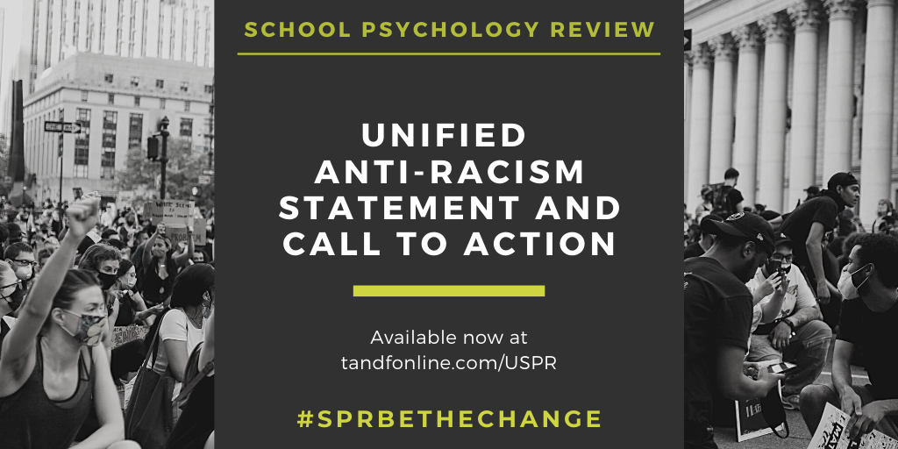

Garcia Vazquez, E., Reddy, L., Arora, P., Crepeau-Hobson, F., Fenning, P., Hatt, C., Hughes, T., Jimerson, S., Malone, C., Minke, K., Radliff, K., Raines, T., Song, S., & Vaillancourt Strobach, K. (2020). School Psychology Unified Anti-Racism Statement and Call to Action. School Psychology Review, 49 (3), 209-211. doi: 10.1080/2372966X.2020.1809941

ALL are INVITED to Endorse and Commit:

Organizations https://ucsbeducation.az1.qualtrics.com/jfe/form/SV_6DSJMBduXKTYwbH

Individuals http://ucsbeducation.az1.qualtrics.com/jfe/form/SV_8bGGcrIlvZblEYl

Sincerely,
VASP Executive Board
Katie Dolak, President
Kelly Acevedo, President-Elect
Terri Sisson, Immediate Past President
Tom Byrnes, Treasurer
Leigh Gahr, Secretary

