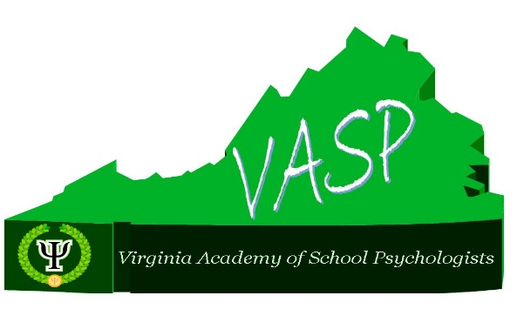
Virginia Academy of School Psychologists
Spring Conference – Preliminary Program

Featuring Dr. Melissa Reeves
Former NASP President, Nationally Certified School Psychologist, Licensed Professional Counselor, and Licensed Special Education Teacher

The DSM-5: Implications for School Psychologists
and
Cognitive Behavioral Strategies for Children and Adolescents: Evidence Based Interventions for the School Setting

Friday April 27, 2018

Doubletree by Hilton
Charlottesville, VA

Registration: www.vaspweb.org
(Scroll to Upcoming Events)
Registration and Fees
VASP Members and Retired Members - $100
Non-members - $200 (It pays to joins VASP before the conference! See website for membership application.)
VASP Student Members - $40

**Please register early. Same-day registration will be available (space permitting) but late fees ($25) will apply.

Questions? Please contact Sarah Nevill, VASP Past President, at snevill@culpeperschools.org.
SCHEDULE

Thursday, April 26, 2018
7:00pm-9:00pm VASP Board Meeting
All VASP Members are welcome to attend board meetings.

Friday April 27, 2018
7:30am-8:30am Registration and Continental Breakfast
8:30am-11:30am Morning Session
11:45-12:45 Buffet Lunch
1:00-4:00 Afternoon Session

Morning Session: The DSM:5: Implications for School Psychologists

This session will provide an overview of the DSM:5 diagnostic categories that most impact children and adolescents. A brief history of DSM development will be provided with emphasis on the current shift from a categorical to a dimensional approach. The relevance of these changes to school-based mental health professionals will be explored. Also included in this session will be discussion of how these changes might influence IDEA eligibility determinations, and the impact these changes will have on accessibility to interventions and community services. Changes to specific diagnostic categories that most impact children and adolescents will be the focus.

Learning Objectives: Participants will
1) Be able to compare and contrast the diagnostic criteria for the DSM-IV and DSM-5 (for selected diagnostic categories).
2) Understand the similarities and differences of using a categorical vs. dimensional approach.
3) Be exposed to new DSM-V diagnostic criteria for those diagnostic categories most relevant to children and adolescents.
4) Identify how the DSM-5 might be used to inform the psychoeducational evaluation.
5) Identify the effect of the new diagnostic criteria on accessibility to interventions and services, both within and outside a school setting.

Afternoon Session: Cognitive-Behavioral Strategies for Children and Adolescents: Evidence-Based Interventions for the School Setting

This workshop will provide participants with specific cognitive-behavioral intervention strategies to utilize with children and adolescents in a school setting. Specific topics to be covered include anxiety, school refusal, depression, ADHD, aggression, traumatic stress, and bullying. The workshop will include an overview of the components underlying cognitive-behavioral therapy (CBT), how to utilize and teach cognitive-behavioral strategies in the school setting, and the integration and generalization of skills to the educational setting and academic instruction. Specific examples of techniques and activities will be shared.

Learning Objectives: Participants will learn
1) The components, basic tenets, and goals of CBT.
2) Understand the research-base and efficacy underlying specific components to CBT.
3) How to utilize and teach cognitive-behavioral strategies in a school setting.
4) Specific types of activities that can be conducted with students.
5) How to integrate and generalize skills to the educational setting and academic instruction.
ADDITIONAL CONFERENCE INFORMATION

Hotel
Doubletree is offering a special group discount of $129 per night for VASP. Go to: http://doubletree.hilton.com/en/dt/groups/personalized/C/CHOSHDT-VAA-20180426/index.jhtml?WT.mc_id=POG
Reserve your room by 03/27/18 to guarantee the special rate.

Meals
Continental breakfast, morning and afternoon snacks, and a buffet lunch are included in your registration fee. For food accommodations or allergies, contact Sarah Nevill at snevill@culpeperschools.org.

Weather and Other Cancellation
In the unlikely event there is a cancellation, we will send a notice to the email address listed in your registration.

Refunds
VASP registration fees are refundable if requests are received by April 19, 2018 at vaspweb.org. After that date, a $50 processing fee will be deducted for the refund. VASP is not responsible for hotel fees or cancellations.

Accessibility
The Doubletree by Hilton is ADA compliant. For special needs, please email Sarah Nevill at: snevill@culpeperschools.org.

Continuing Education Credit
VASP is approved by the National Association of School Psychologists (NASP) to offer 6 hours of NASP-approved professional development for school psychologists that attend the conference in it’s entirety. VASP maintains responsibility for the programs it offers.

Vendors
Tables will be available for vendors or for school systems that would like to recruit school psychologists. Contact Sarah Nevill (email below) for pricing and details.

Questions? Please contact Sarah Nevill, VASP Past President, at snevill@culpeperschools.org.

